GIT AND GITHUB – 2

- git branch –list
to see how many branches are available in our project
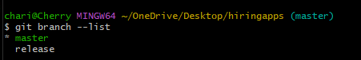
- git branch release
to add a branch
*represents our current branch
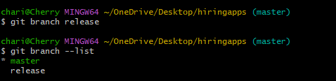
- git checkout release
if we want to switch the branch
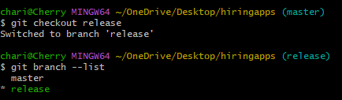
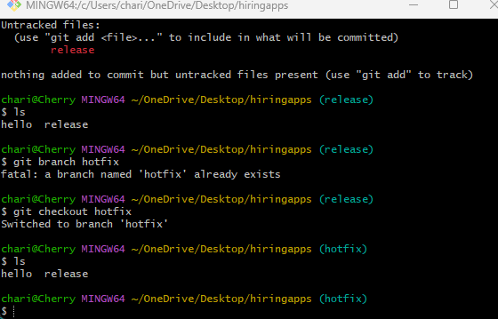
Merge branch
